

**QUESTION BANK**

**GRADE: 1**

**CHAPTER: Keeping safe.**

1. Colour the traffic lights.

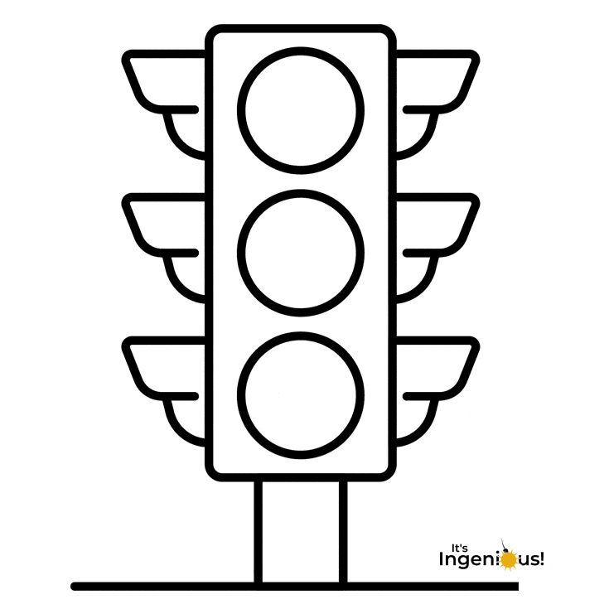

1. **. Write True/False**

1. Do not play with sharp things.

True

2. Always touch electrical sockets and switches.

False

1. Cross the road at zebra crossing.

True

1. Put hands and head outside the moving bus.

False

5. Stranger is a person whom you dot know

True

6. Do not take anything from a stranger.

True

7. Allow a stranger to hug and kiss you.

False